# User Guide

Q - How to start a server?

1. Start Catan.jar and click on “**Start Server**”

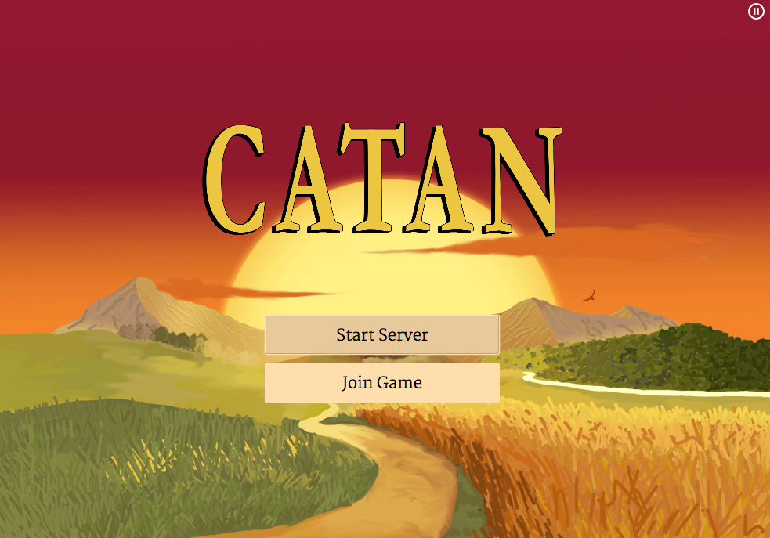

2. Enter maximum **number of players** and preferred **type of game board** and **number of artificial**

**players** you would like to play with and click on “**Start Server**”

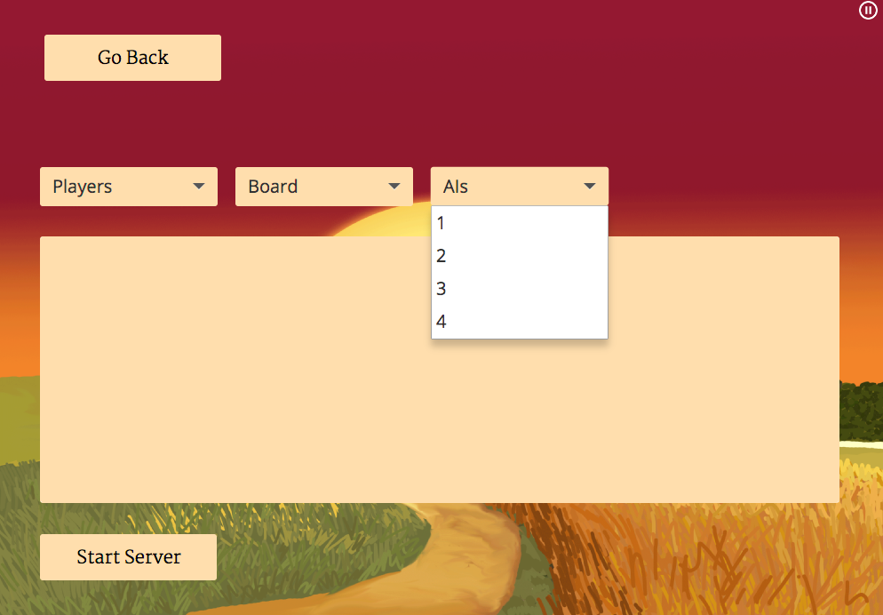

## Q - How to join a server?

1. Open **another Catan.jar,** click on “**Join Server**”. Enter the **address of the server** and choose whether the player is an AI or if you want to play yourself.  Then click on “**Connect**.”

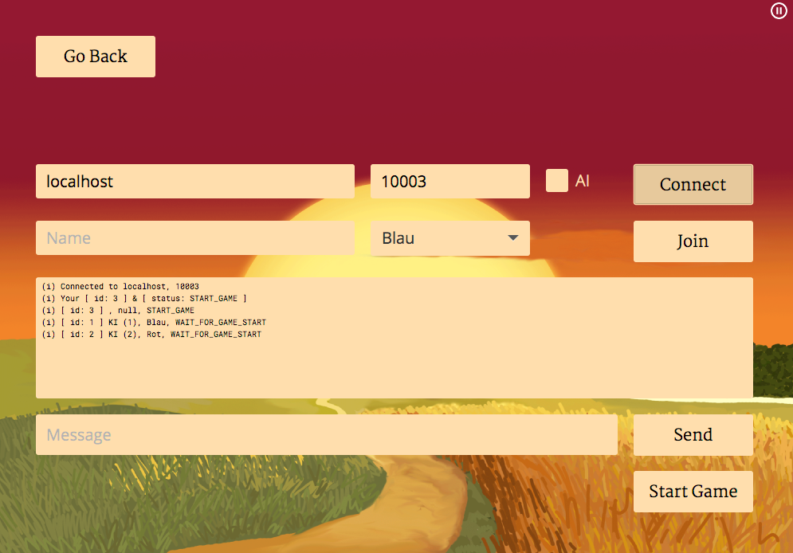

2. Enter **name** and choose **color**. Then click on “**Join**” and “**Start Game**.”

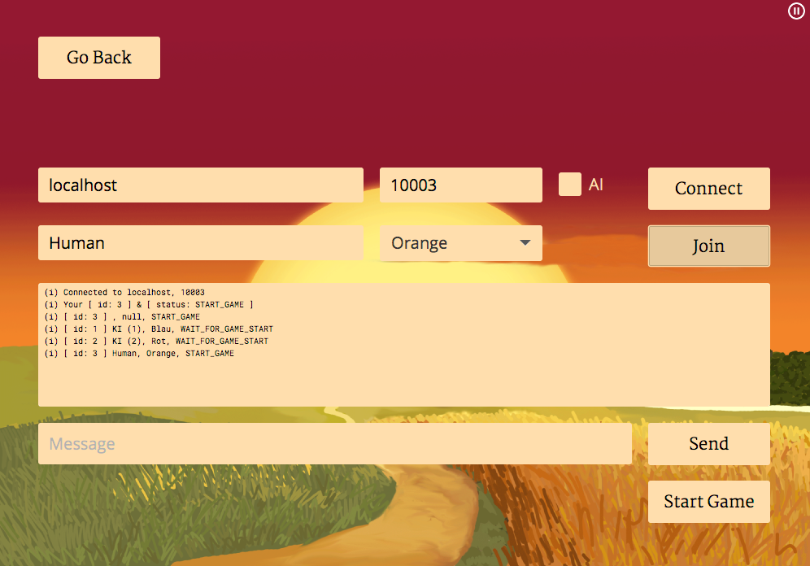

## Q - How to play the game?

1. The left column shows the stats of the other players.
2. The right column is a chat window to converse with the other players.
3. The lower part of the window is your control menu. On the left side are buttons to roll the dices and end your turn. The middle part shows your status and amount of resources you own.
4. The button with two shaking hands is for trading and the buttons on the right are being activated,
5. when you own enough resources for building settlements, cities or streets or to buy a development card. The landing stages symbolize the corners by the Sea that offer maritime-trading. The resource symbols on the sea-tiles closest to the chosen landing stage show the required trade-resource type.

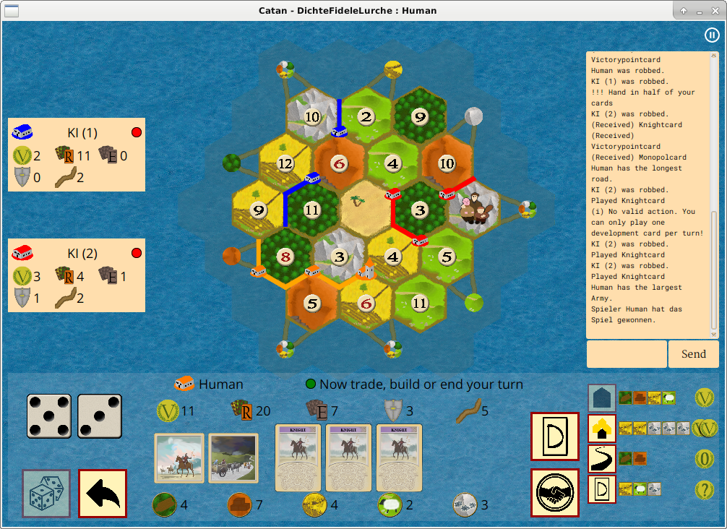



1. Build
2. In the first two rounds the corners where you can build your free settlements appear automatically. Afterwards the possible corners are also shown, when clicking on the “Settlement” button.

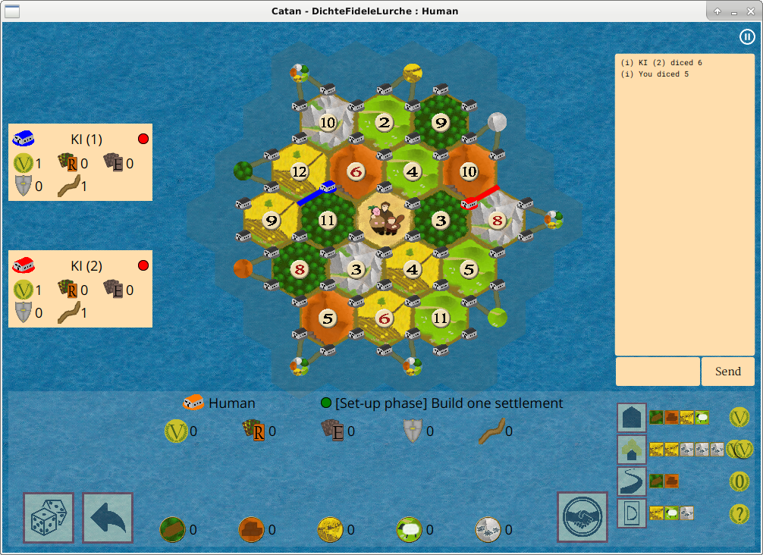

The same procedure applies to building cities.

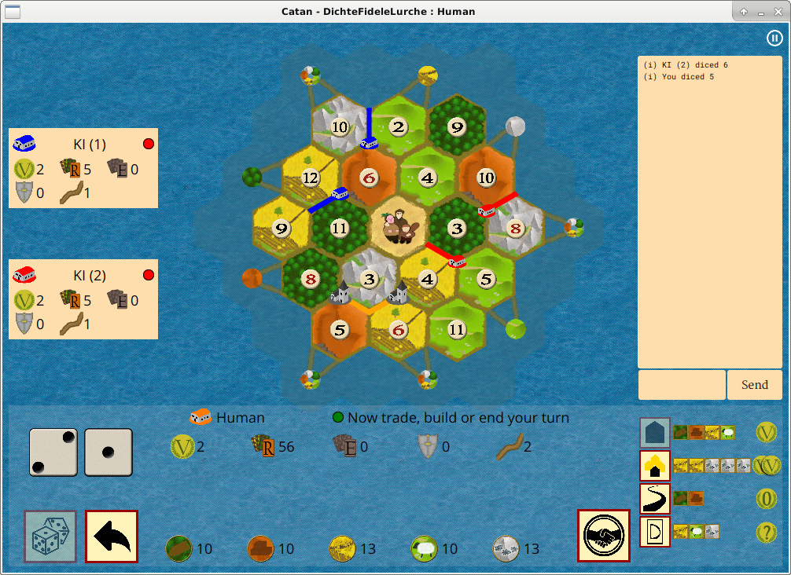

After clicking on the corner where you want to build your settlement the possible positions where you can build a street are also shown.

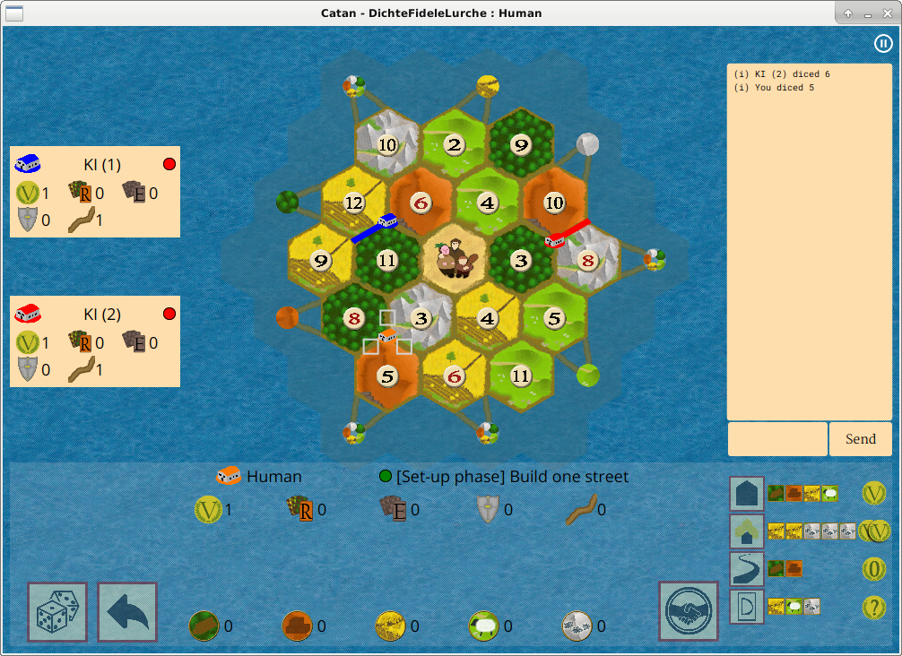

1. Trade

When you click on the trade-button another window opens which shows the possible trading options. The buttons to trade with a specific harbor only appear if you have a settlement or city at that harbor.

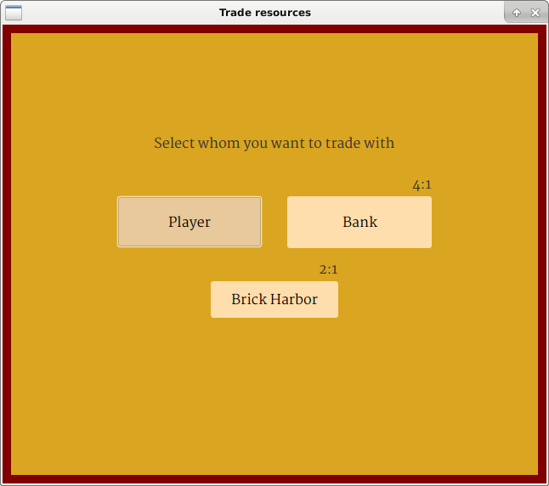

2.1. Maritime Trade

When you choose trading with a specific harbor, another window appears, which lets you choose

how many resources you want from that harbor. The OK-Button only activates when you have entered enough specific resources.

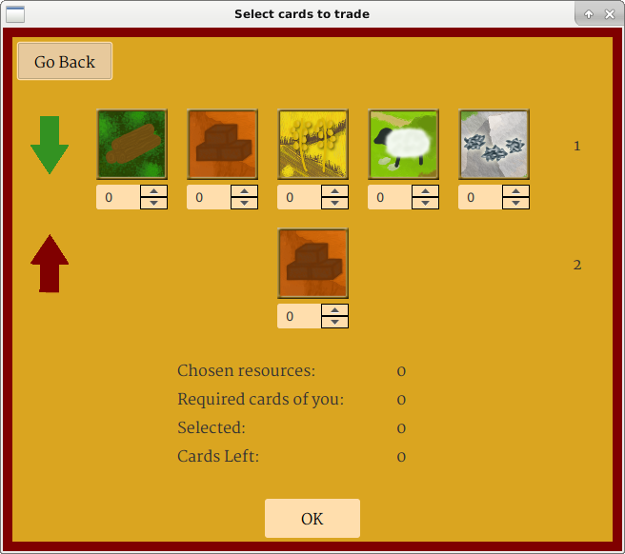

2.2. Domestic Trade

Trading with another player lets you choose which resources you are willing to give and which ones you want to have. Click on “Send” to send out your request to all other players.

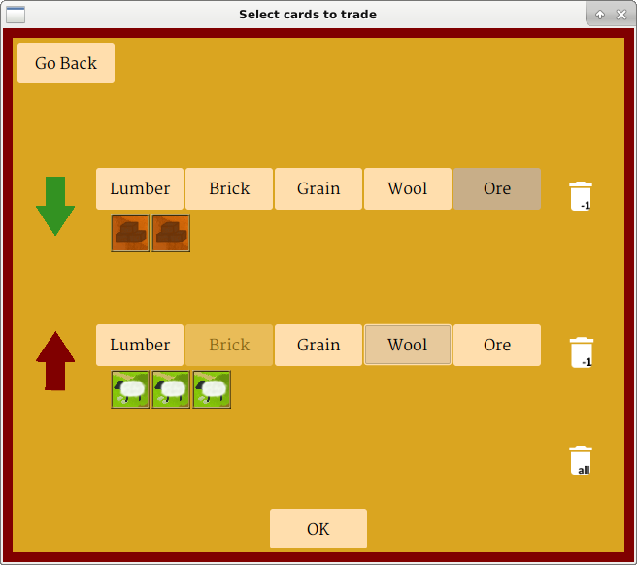

Afterwards another window opens showing who has accepted, declined or is still waiting.

When the other player accepts the “Trade”-Button activates and by clicking on that button you perform the trade with the chosen player.

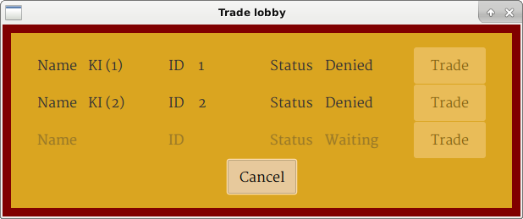

If another player sends out a trade request, you will receive a window asking whether or not you would like to accept.

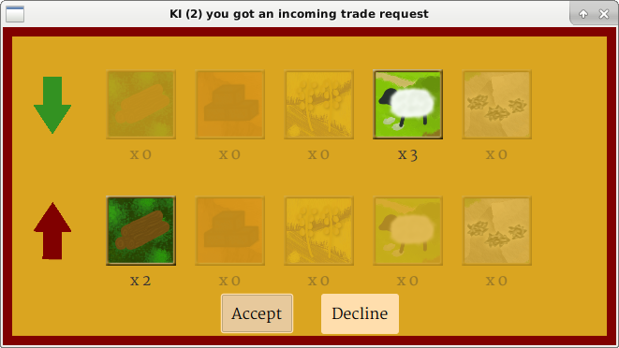

If you do not have enough resources to perform this trade, you will be automatically directed to the “Trade Lobby” above and your status will be set to “Denied.”

1. Development Cards

After buying a development card you can use it by first clicking on the button with the large D above the trading button in your own status box and second clicking on the development card you would like to play. If you have more than 3 cards, you can click on the outer sides of your first or last card to move left or right in your stack of Development Cards.

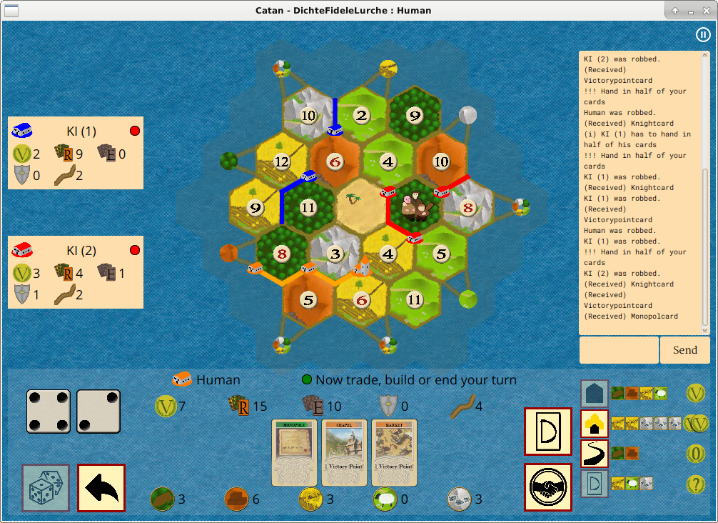

1. Robber

When rolling a seven or using a knight-card you can move the robber, possible positions will be shown.

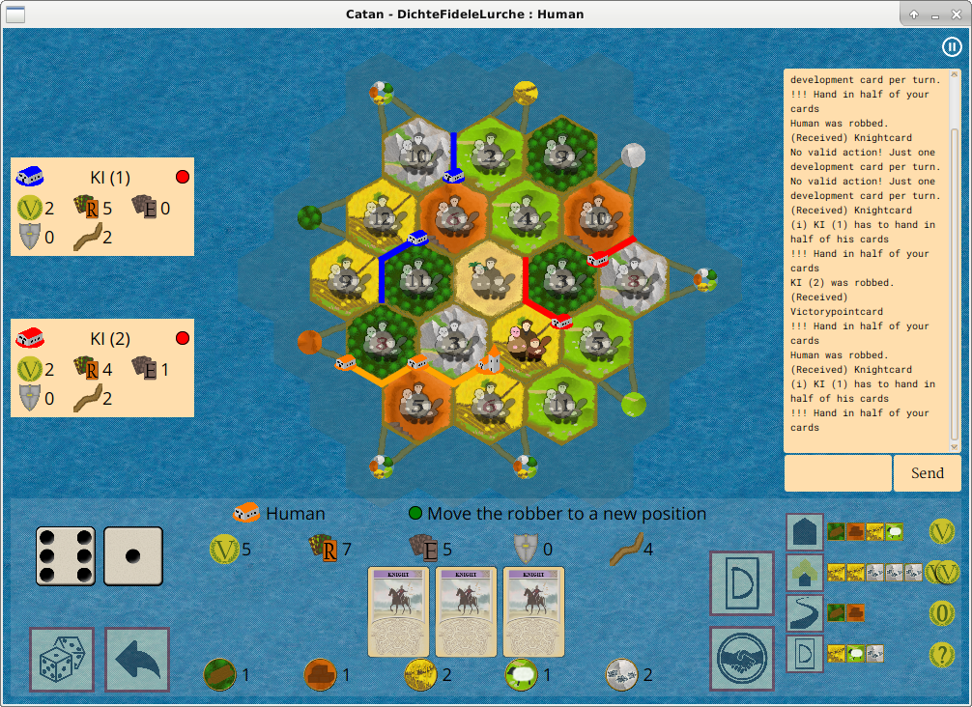

If you have more than seven resources, you will be asked to hand in half of your resources.

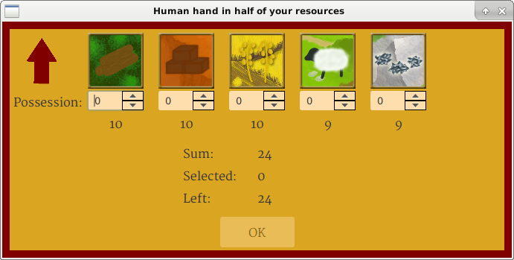

1. Largest Army and Longest Street

Once you have the Largest Army or the Longest Street, the icons will appear in your status box.



1. End

Once a player has reache ten Victory Points, a Pop-Up will automatically  appear, stating the name of the winner and once you hit the OK-Button, the whole game shuts down.

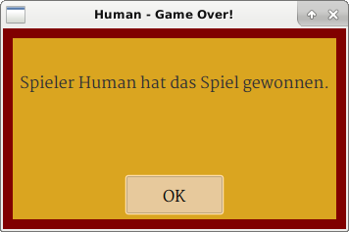

1. Cheats

Type “**cheaton**” into your chat window to active cheats (this activates cheats for every player) and

enter “**+10**” for getting ten more resources of each resource,

“**+2**” for getting the turn and two more resources of each resource,

“**psst**” for seeing all resources the other players own,

“**devcard**” for getting the exact amount of resources needed to buy a Development Card,

and “**mop**” for getting a Monopoly Card.